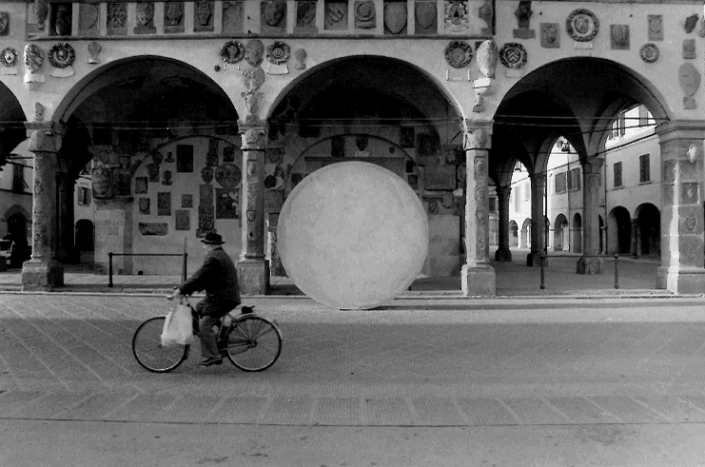
Artist Residencies in
Contemporary Renaissance
2nd Edition
(for under 35 Indian artists and curators)
2

promoted by

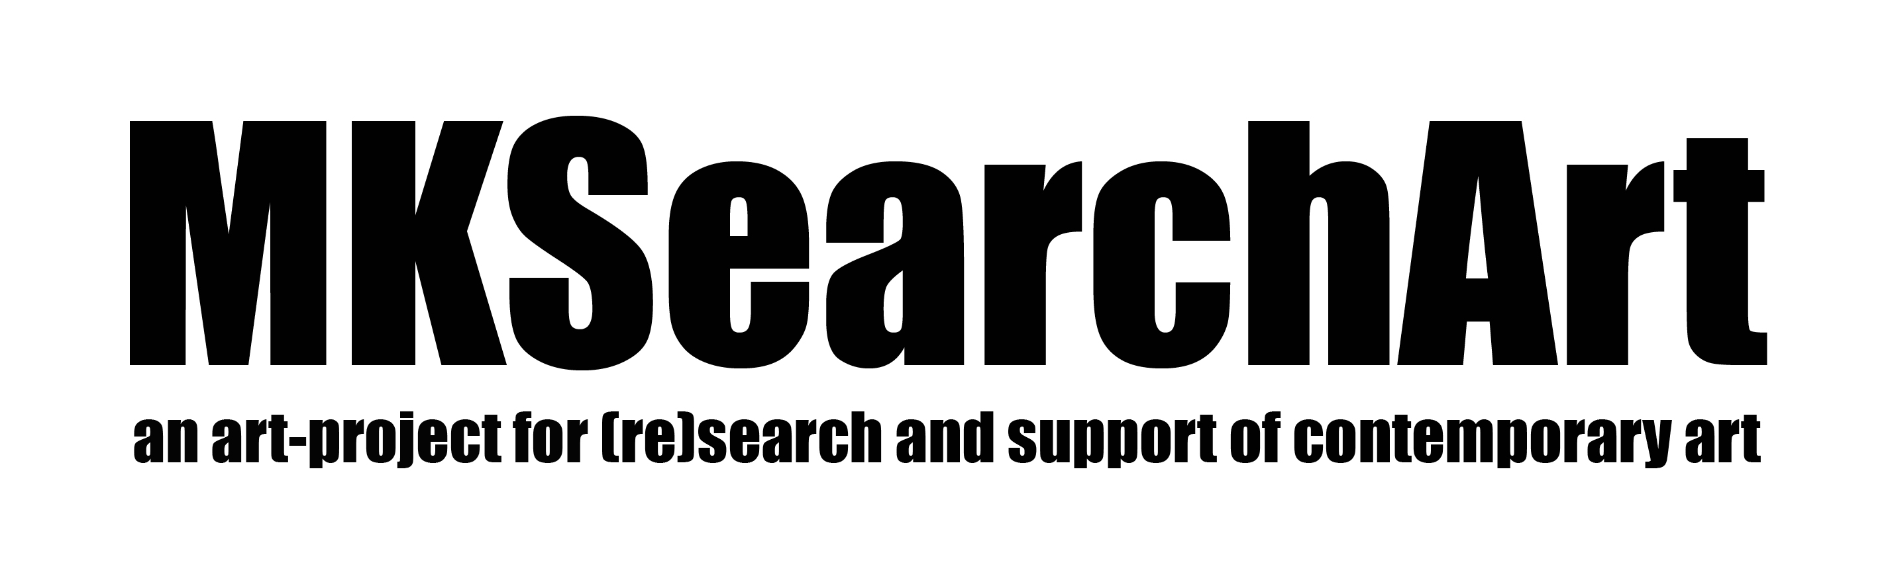

a permanent platform for international artist's residencies in the heart of Italy





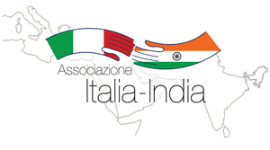




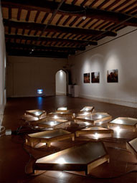
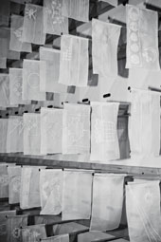

. How many residencies? 3/4 artists + 1 curator

. Duration program? 1 and a half month

. When? November - December, 2013 (+show)

. Application deadline? August 31, 2013

. Contacts? info@mksearchart.com

Within the heart of Italy, at San Giovanni Valdarno (Tuscany) in the house where was born the great Master Masaccio, one of the most relevant figures of the XIV Century Renaissance period, together with Leonardo Da Vinci, Donatello and Michelangelo, a permanent platform for International artist's residencies has been founded in 2012.

The project has been designed by "Casa Masaccio" Centre for Contemporary art with the Municipality of San Giovanni Valdarno, and MK Search Art cultural Association which has been promoter of the widely celebrated Indian Pavilion of Prague Biennale 5 aside from some collateral events at the MAXXI of Rome.

The selected artists will be hosted in Palazzo Salviati, a XIV Century charming structure with original paintings and the noble's crests of some of the ancient italian families. Just few steps from the finely restructured apartments of Palazzo Salviati - within the historical centre of San Giovanni and close to the municipal collection of contemporary art - there are the exhibition spaces and the studios fully equipped so as to place the artist in the best conditions to work on their ideas.

The land surrounding San Giovanni (where itʼs hosted moreover one of the most renowned "Annunciation" by Beato Angelico) offers naturalistic insights of particular interest, being immersed in the bucolic tuscan countryside which has inspired some immense yesterday and today masters, but at the same time the place itʼs close to the beaches of the fascinating west coast of Italy.

On the other hand, the area offers deep cultural insights, since Florence is nearby and the Eternal city, Rome, it's just over an hour far. Than Milan, world capital of fashion and design, is 3 hour panoramic train away from there.

An high qualified team follows the artists by time they will be selected, and a personal tutors will be at the disposal of each participant during the residency period. Study tours, worships, visits and cultural meetings both with academies and institutions are part of the project which has been meticulous prepared.

But the experience in San Giovanni Valdarno will be further enriched on the base specific requests from the artists: the scope is to create an unique and very personal experience for the artist inspired by the values of creativity and renovation on which is founded the Tuscan Renaissance that have changed the Europe. From the XIV to the most actual and contemporary contest.

There are no age limits or restrictions of any kind. A Commission will carefully process the applications and a response will be given to all the candidates. That's why is highly recommended a particular attention in filling the application form, closely choosing the materials and presenting a draft project for the residency program. A final show (with catalogue) in Tuscany will close the 1 months residency program.
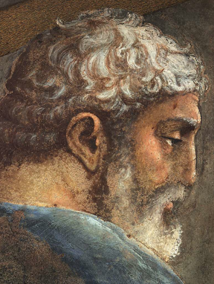
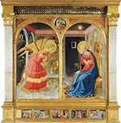
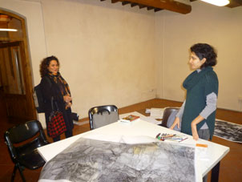

In the cradle of the European Renaissance, among incredible landscapes and unique culture sites
Working in Contemporary art spaces and equipped studios

Annunciazione, Museo Basilica “Santa Maria delle Grazie” San Giovanni Valdarno

Artist’s apartments

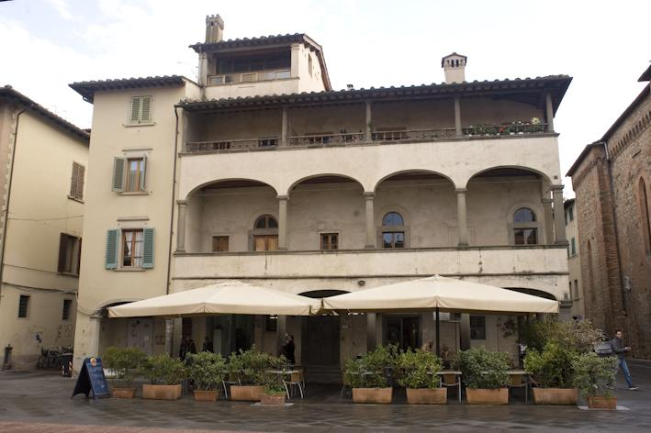
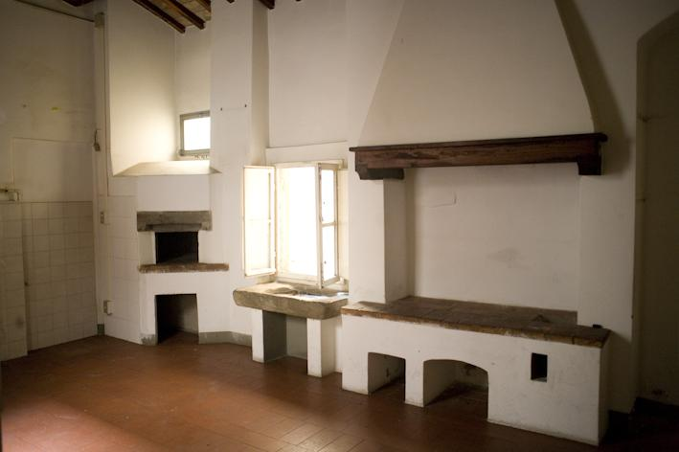

Outside: Palazzo Salviati Inside: kitchen

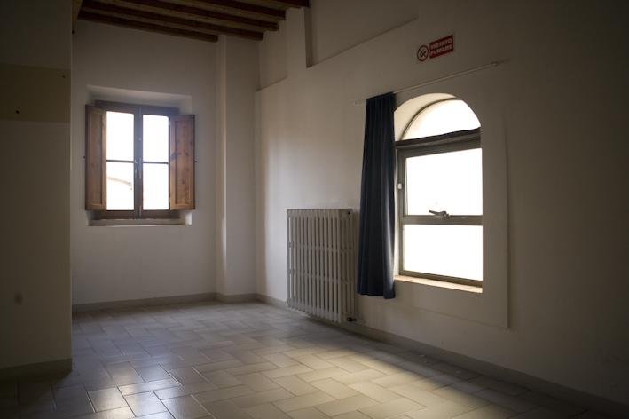
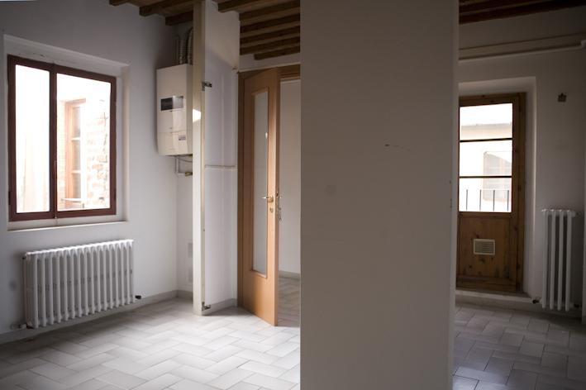

Inside: living room (1) Inside: living room (2)

Studios AND exhibition space
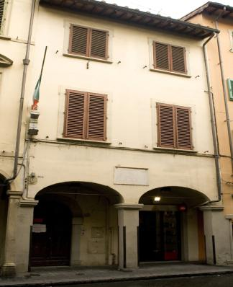
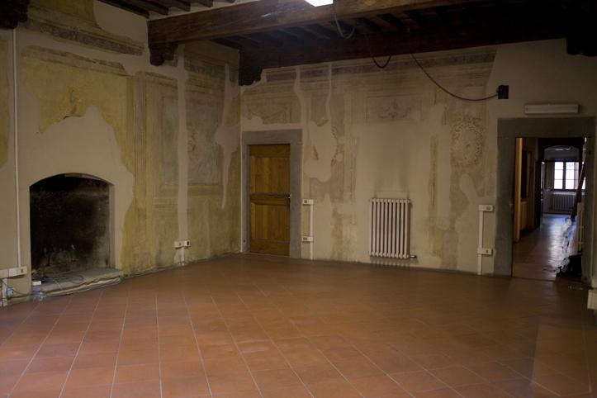
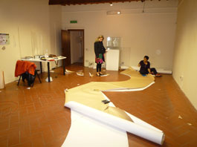

Outside: Casa Giovanni Mannozzi Inside: Studio space (1) Inside: Studio space (2)

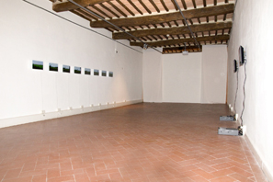
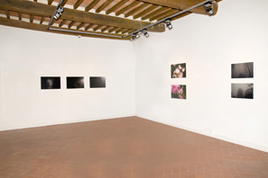
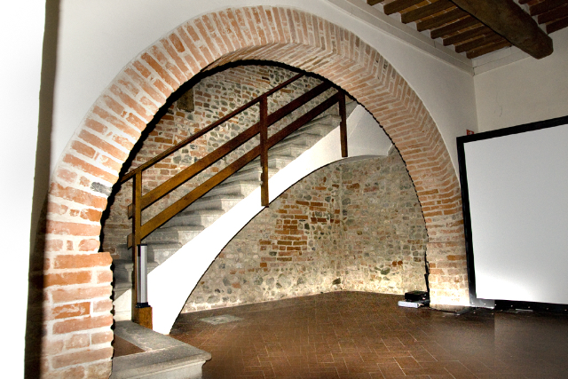

Casa Masaccio Exhibition spaces

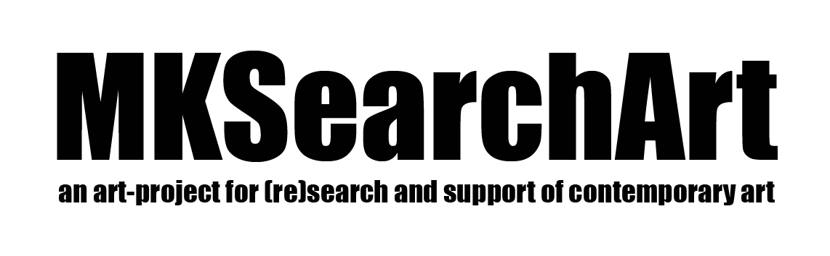

Application Guidelines
- Application form is available in English
- All fields are mandatory
- "Covering letter" should always be in English and no longer than a A4 page (max. 2500 characters including spaces)
- Applications will be assessed by the Organization and notification of the Jury's decision is made by e-mail no latter than 2 weeks after the application deadline. Please note that the Jury's decisions are final.

Please provide
- Completed Application Form

- One page Covering Letter outlining your residency objective and intentions during your time in Italy

- A Resume/CV outlining artistic accomplishments, awards, exhibitions, published works. Copies of recent articles, reviews, and catalogues would also be useful

- A list of equipment needs indicating what you will provide and what you'll need to source in Italy so that we can advise you on feasibility

Materials should be sent to info@mksearchart.com. Please feel free to contact us for any doubts or further considerations via luciano.donatini@mksearchart.com

Application Form

PERSONAL DATA
NAME .....................................................................................................................................................

SURNAME ...............................................................................................................................................

ADRESS ..................................................................................................................................................

ZIP CODE .................... CITY ......................................................... COUNTRY .....................................

PHONE ........................................................................................... FAX ..............................................

E-MAIL ........................................................................................... (if any) WWW …...............................

PLACE AND DATE OF BIRTH ...................................................................................................................

PREVIOUS PARTICIPATION IN OTHER RESIDENCE PROGRAMS ................................................................................................................................................................

................................................................................................................................................................

................................................................................................................................................................

................................................................................................................................................................

ATTACHMENTS (as mentioned above):
1 Covering letter
2 Resume/CV
3 List of equipment desired

AGREEMENT:
I hereby abide to the rules of the “Casa Masaccio” Museum and would like to avail the Residency 2013 programs.

DATE ................................................... SIGNATURE .............................................................................

Terms and Conditions

"Contemporary Renaissance" is artists AND curators residency program dedicated to under 35 Indian artists and curators, organized by Casa Masaccio with the Municipality of San Giovanni Valdarno, and by MK Search Art (the "Organization")

Residency duration is 1and half month, based in San Giovanni Valdarno (Tuscany).

Applications deadline is August 31, 2013 for the cycle taking place in Autumn 2013.

The Organization selects 3/4 artists and 1 curator for each residency cycle.

Minimum age for participation is 20, maximum is 35.

Participants travel costs are covered by the Organization, and cover round trip flight ticket (economic class) to Italy plus local trains an transports to reach San Giovanni Valdarno. The Organization will take care of the logistic plan of each residency’s participants.

The residency include an accommodation in fully furnished flats (single room is guaranteed for each participants) in San Giovanni Valdarno historic buildings situated in the ancient city center. Each flat have drinking water and services, electricity, gas and an equipped kitchen, Internet. Cleaning service (before arrival / after departure) is comprised.

Meals (lunch and dinner) in San Giovanni Valdarno ARE included in the hospitality. As far as possible, particular menus will be also provided considering food allergy or intolerances previously communicated by the selected participants.

Residency offers the use of a large atelier/studio space equipped (general usual tools) for the artists/curator.

A € 400/participant honorarium is provided by the Organization.

A € 1000 per artists maximum budget has being enstablished for the works’ production, unless otherwise decided in mutual agreement between the artist and the Organization.

Organization provides production management of artworks, including research of material supplier and technical support. Minor production expenses, related to availability of the technical equipment at disposal of the Organization.

A selection of studio visits/ cities visits/ talks/ presentations are provided. Sightseeing, visits to Galleries/ Exhibitions/ Museum will be also planned considering eventual participant’s requests.

A qualified Staff will stay in San Giovanni Valdarno at the disposal of the residency participants for the entire period of the residency.

The Organization selects two works made during the residency by each artist to be donated to the Organization. Other works done during the period are the property of the artist and will be eventually kept on consignment just for the duration of the show.

Afterwards the residency program, a group show will be held at Casa Masaccio Museum. A fully catalogue of the show will be published.

No artist will be allowed to take leave/ break for other engagements during the residency, rather then that of the Museum.

AGREEMENT:
I hereby abide to the above Terms and Conditions of the “Casa Masaccio” Museum and would like to avail the Residency 2013 programs.

DATE ................................................... SIGNATURE .........................................................................................

